llllllllllllllllllllllll llll IIDl l111111111111
Cert: 24872 Doc: AMENDME
Registered: 01/13/2020 02:36 PM

FIRST AMENDMENT TO

LOCAL INTITIATIVE PROGRAM REGULATORY AGREEMENT
AND
DECLARATION OF RESTRICTIVE COVENANTS FOR
OWNERSIDP PROJECT
"SANDPIPER PLACE II" (NORTH) WORKFORCE HOMEOWNERSHIP DEVELOPMENT PROJECT

This First Amendment to Reg ry Arnnt and Declaration of Restrictive Covenants (this "Amendment") is made this ;}{) day of 'Oil ,2019, by and among the Commonwealth of Massachusetts, acting by and through the Department of Housing and
Community Development ("DHCD"), pursuant to G.L. c. 23B §1 as amended by Chapter 19 of the Acts of 2007, the Town of Nantucket (the "Municipality"), and Richmond Great Point Development, LLC, a Delaware limited liability company, having an address at 23 Concord Street, Wilmington, Massachusetts 01887, and its successors and assigns (the "Developer").

WITNESSETH:

WHEREAS, DHCD, the Municipality, and the Developer are the parties to that certain Regulatory Agreement and Declaration of Restrictive Covenants (the "Agreement"), dated as of May 3, 2019 and registered as Document No. 161880 with the Nantucket County Registry District of the Land Court; and

WHEREAS, the Agreement provides that Low and Moderate Income Units will be sold for no more than the price set forth in Exhibit B to the Agreement; and

WHEREAS, subsequent to the execution and registration of the Agreement, HUD published updated the area median incomes (for the year 2019) establishing, in part, the sales prices for Low and Moderate Income Units set forth in the Agreement; and

WHEREAS, pursuant to the Agreement DHCD, the Municipality and the Developer have agreed to amend the Agreement to memorialize the updated sales prices for which Low and Moderate Income Units will be sold to Eligible Purchasers; and

WHEREAS, after giving effect to this Amendment, the Low and Moderate Income Units will remain as SHI Eligible Housing, subject to the remaining terms and conditions of the Agreement;

NOW, THEREFORE, in consideration of the agreements and covenants hereinafter set forth, and other good and valuable consideration, the receipt and sufficiency of which each of the parties hereto hereby acknowledge to the other, DHCD, the Municipality, and the Developer hereby agree and covenant as follows:

- Amendment to Agreement. The text of the Exhibit B to the Agreement shall be deleted in its entirety and replaced with the following text:

"Re: SANDPIPER PLACE II (NORTH) WORKFORCE HOMEOWNERSHIP DEVELOPMENT PROJECT
RICHMOND GREAT POINT DEVELOPMENT, LLC NANTUCKET, MA

Maximum Initial Sales Prices, Initial Homeowners Association Fees, and Percentage Interest Assigned to Low and Moderate Income Units

Initial Sales Price HOA Fee %Interest

One-bedroom units  Two-bedroom units | $_n/a_  $244,200 | $- n/a---  $_40 Per Mo. | - n/a-- 1.92%
Three-bedroom units | $271,900 | $_40 Per Mo. | 1.92%

Four-bedroom units $_n/a_ $_n/a
- n/a--

Location of Low and Moderate Income Units

The Low and Moderate Income Units are those designated as lot numbers 5, 59, 63*, 67, 74, 77, 81*, 86, and 89 on the Sandpiper Place I and II Homeownership Development Project Lot Allocation Site Plan, attached hereto.
*Lots 63 and 83 contain duplex dwelling units that are all Low and Moderate Income Units. Accordingly, Lots 63 and 83 include four (4) Low and Moderative Income Units in total."

- Confirmation. Except as hereinabove amended, the Agreement shall remain in full force and effect. Except as otherwise herein defined, capitalized terms shall have the same meaniog as given to them in the Agreement.

THE REMAINDER OF THIS PAGE IS INTENTIONALLY BLANK. SIGNATURES APPEAR ON THE FOLLOIWNG PAGE(S).

2

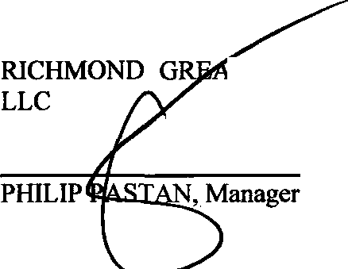IN WITNESS WHEREOF, the parties hereto have caused this First Amendment to Regulatory Agreement and Declaration of Restrictive Covenants to be executed as a sealed instrument as of the day and year first above written.

T POINT DEVELOPMENT,

DEPARTM OF HOUSING AND COMMUNITY DEVELOPMENT
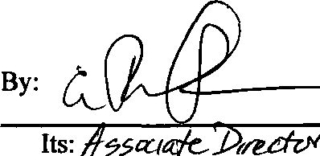

TOWN OF NANTUCKET
By its Board of Selectmen

By:liu Dawn E. Hill Holdgate, Chair

COMMONWEAL TH OF MASSACHUSETTS

COUNTY OF/llltldlgq/, ss.
w. ,

public, personally appeared PHILIPASTAN, proved to me through satisfactory evidence of identification, which were a( f,,{tt,bt11l'!::f.4';_ ,to be the person whose name is
On this //ff,,. day of
2019, before me, the undersigned notary
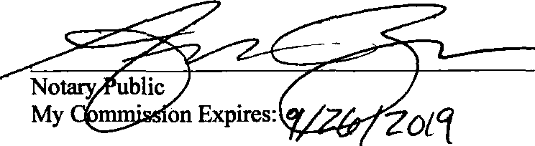
signed on the preceding document,• as Manag of RICHMOND GREAT POINT DEVELOPMENT, LLC and acknowledged to me that he signed it voluntarily for its stated purpose.
'"\\\'\f\\fIIIIIIJ/1.r.

§ <I:;...
D. 13 ,,,,,.
iss10'i/· /f"Y.

:/:: .•c;P.t9ER -2•
=
!:: 1111:t'A: _4 • o •• r
- - ;.>' • -
-- .:-g"' "' ..: ==-
; •;a - ,,_ i).:
-. · !P·
1:0••.'1/l}i OF ti ';<;;•••,CJ$°
,,,. n\) ':- :,.'... ,- ."
z,,., /•./•R••y•••• r\, ,;:_..; 3
.:,·111111\\\\.•

COMMONWEAL TH OF MASSACHUSETTS

COUNTY OF SUFFOLK, ss.
On this ,Y: day f.) ,2019, before me, the undersigned notary public, personally appeared _J Ylff:!li !....t 1._------,---,--, 1 proved to me through
satisfactory evidence of identification, which were , to be the person whose name is signed on the preceding dotument, as 77 for the Commonwealth of Massachusetts acting by and through the Department of Housing and
A
Community Development, and acknowledged to me that he/she signed it voluntarily for its stated purpose.

Notary Public
My Commission Exp·
s:
,..,.
0
,,._ -:.SE.RT .
?
-1:t!X" ORll:I .
.- .
@
>::,;··Noiary•P:: r,tll)SETTS
COM: :on Expires
..
March 11, 2022

COMMONWEALTH OF MASSACHUSETTS

COUNTY OF NANTUCKET, ss.
On this 2V day of OtnW , 2019, before me, the undersigned notary public, personally appeared Dawn E. Hi! Holdgate, proved to me through satisfactory evidence of identification, which were L-- to be the person whose name is signed on the preceding doc ent, as Chair of the Bo of Selectmen for the Town of Nantucket, and acknowledged to me that she signed it voluntarily for its stated purpose.

Notary Public Print Name:
My Commission Expires:

.
fj
ERIKA DAVIDSON M
....... ....
NOlafYl'UbllC
OOMEY
My Qom,nlMIO,II ....
0, ., .. ,CIIJll"ffl

·.--',

, \ 1, / I
'I,,1 \ /

DOC Ho• 00164247

,. /'
. I,_.

I \
, I
,\,'
: /' , \
I lt \ I ( /
·, /;'?:,';,' /,·,:-,:',
., , \'
{
NANTUCKET COUNTY LAND COURT
REGISTRY {)JSTRlc:T

** RECEIVED FOR R£GISTRhTI011 H

·.-; .,. r1 . ; I ' ) \'

.. !_/
•,, '·1•

...:-:::.:..--
... --
on: Jan 13,2020 ot 02:36f'
DDcun1ent Fee: 210.00 Re, Totul:$94'5.

:I
- !!l'f''" " g
.,. .' I
·

- --••------ -e•• -----•,-••----- --

GERTIFICATE I-lo• 24872

.,, "' t 'e ;::
--------·-·--·- ------ ----- -- . ·--

.. -c.; ii
~
fo cs
I

"'O
:a
3-· O,.<;o
Al so noted on CERT 1552'.5

< 5 <I
oo s►
i
s< g
g
Co:

